

Asana Developer Advocate Takehome Exercise

Asana API



September 30, 2018

Alvin Lawson

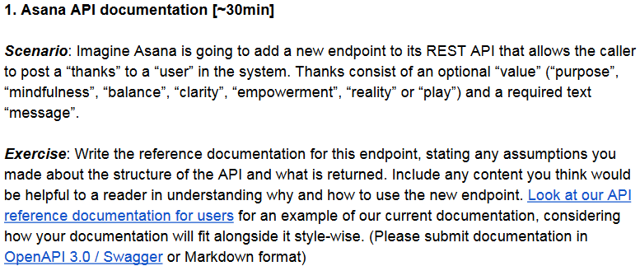

**Exercise #1:**

* [Click Here for Markdown](https://github.com/al11588/AsanaDeveloperAdvocateAssignment): **Inside the .zip folder named README.md.**

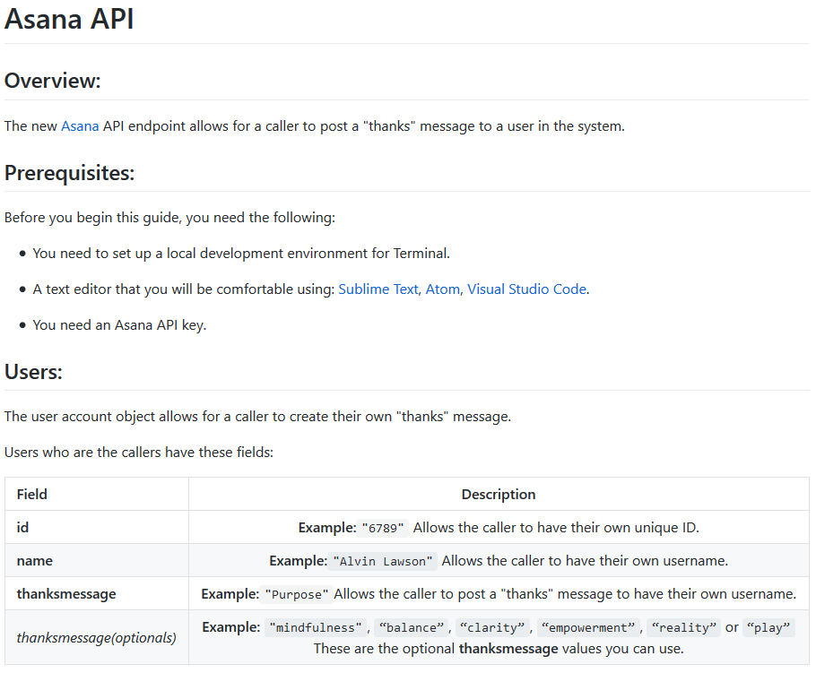

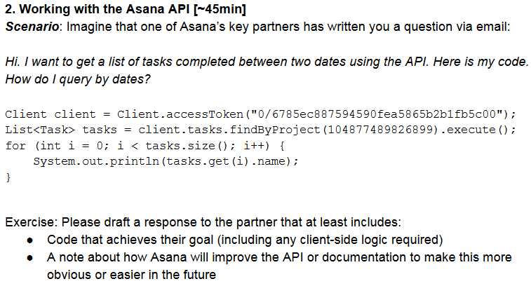

**Exercise #2:**

Hello Dustin Moskovitz,

I hope all is well. This is Alvin Lawson from Asana. I had some time to look at the code that you sent me and I have a suggestion. One suggestion in terms of querying by dates in the code would be going to the fourth line and editing **name** within the **println** method to “**System.out.println(tasks.get(i).date);”.** I am sorry that you are having issues in understanding our API documentation. In an effort to improve our API documentation in the future, we invite you to participate in a brief survey to tell us how Asana is meeting your expectations. Your participation is voluntary and your answers will be anonymous. If you have any more questions please feel free to message me back.

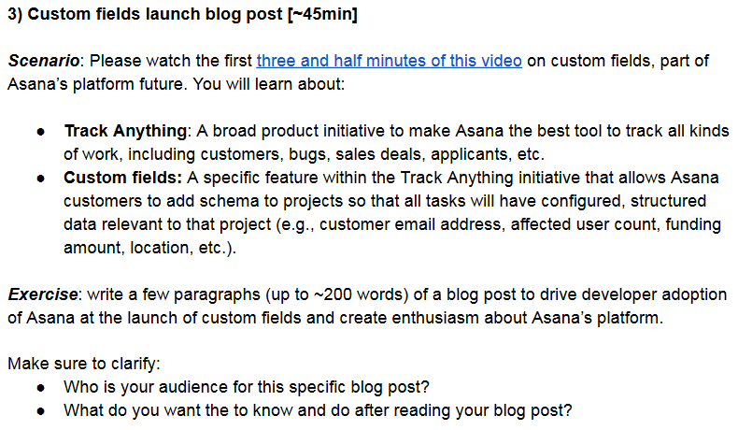

**Exercise #3:**

**Custom Fields: A new way to track**

Today we have a big update to share. Custom fields are now available for all partners on Asana. In 2015 we successfully launched Track Anything. Track Anything is a tool that allowed our partners to track all kinds of work that include bugs, sales deals, applicants etc. We heard our partners feedback on what we needed to improve on Track Anything and are now introducing Custom Fields. Custom fields are a new feature that allows our partners the freedom to add schemas to their own projects.

Adding schemas help to add relevant data to your own project. For instance, if you are an investor you can add a CEO email address, the funding amount and location to your project. No more going through your email inbox to search for information relevant to your project when all your data is right in Asana’s custom fields. If you have any questions please feel free to reach out to me via email: [alvin@asana.com](mailto:alvin@asana.com).